INDIA’S AGRICULTURAL CROP PRODUCTION

INTRODUCTION

*PROJECT DESCRIPTION:*

India is a global agricultural powerhouse, ranking among the top three producers of many crops, including rice, wheat, pulses, cotton, peanuts, fruits and vegetables. It is also the world's largest producer of milk, jute and spices. India's agricultural sector is vital to the country's economy, providing employment to over half of the population and contributing significantly to GDP.

Major agricultural crops produced in India:

Food crops: Rice, wheat, pulses, maize, sorghum, bajra, jowar, barley, oilseeds, fruits and vegetables

Non-food crops: Cotton, jute, sugarcane, tobacco, tea, coffee, rubber, spices

India's agricultural crop production trends:

India's agricultural crop production has grown steadily over the past few decades, despite the challenges of climate change, land degradation and water scarcity. In 2022-23, India's foodgrain production is estimated to reach a record 330.5 million tonnes, up from 314.9 million tonnes in 2021-22. This increase is attributed to favorable weather conditions and government initiatives to support farmers.

Factors contributing to India's agricultural growth:

A number of factors have contributed to India's agricultural growth in recent years, including:

Government support: The Indian government has implemented a number of policies and programs to support farmers, such as providing subsidies on inputs, offering crop insurance and investing in irrigation infrastructure.

Technological advancements: Indian farmers are increasingly adopting new technologies, such as high-yielding seeds, precision agriculture techniques and drip irrigation, to improve their productivity.

Market reforms: The Indian government has implemented a number of market reforms to improve the efficiency of the agricultural sector, such as liberalizing agricultural trade and deregulating the fertilizer and seed industries.

Challenges facing India's agricultural sector:

Despite the progress made in recent years, India's agricultural sector still faces a number of challenges, including:

Climate change: Climate change is a major threat to India's agriculture, with more frequent and severe droughts, floods and heatwaves.

Land degradation: Soil erosion and salinization are major problems in India, reducing the productivity of agricultural land.

Water scarcity: India is a water-stressed country, and agriculture accounts for over 80% of water use.

Small landholdings: The average landholding size in India is very small, which limits the adoption of new technologies and economies of scale.

Post-harvest losses: Post-harvest losses of agricultural produce are estimated to be around 25-30%, which is a major drain on the economy.

PROBLEM DEFINITION & DESIGN THINKING:

EMPATHY MAP



IDEATION & BRAINSTORMING MAP

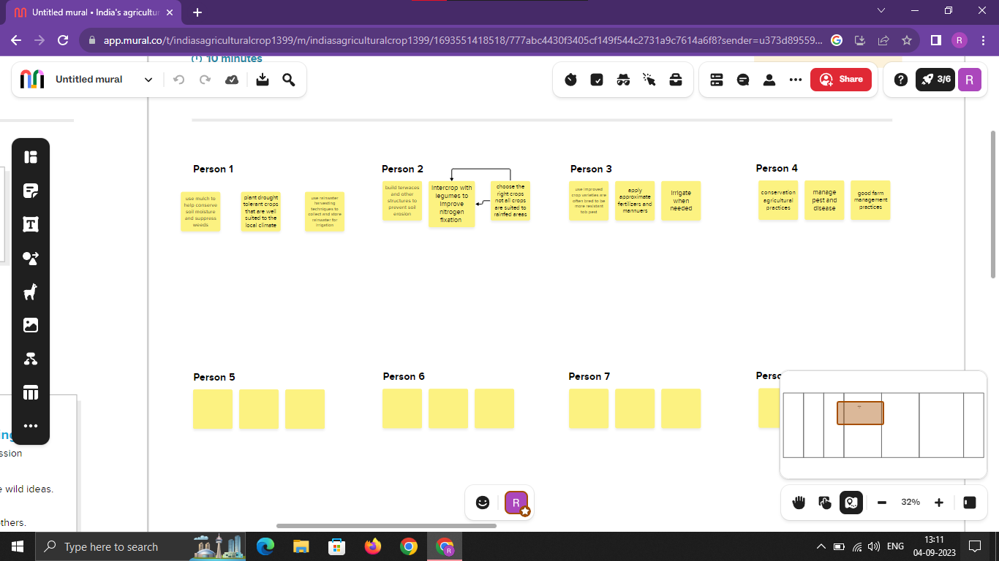

Result

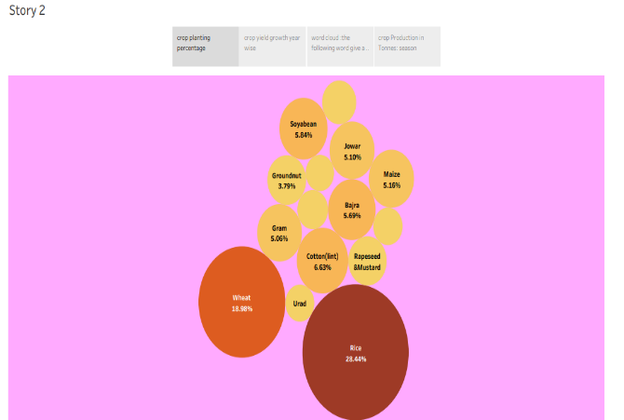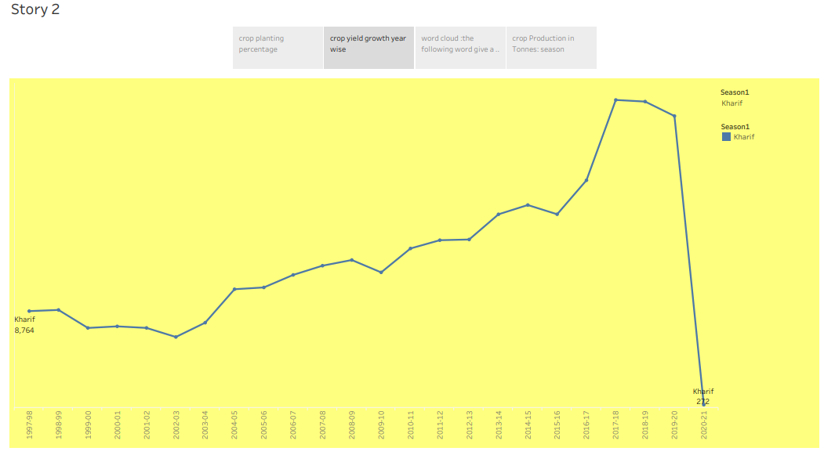

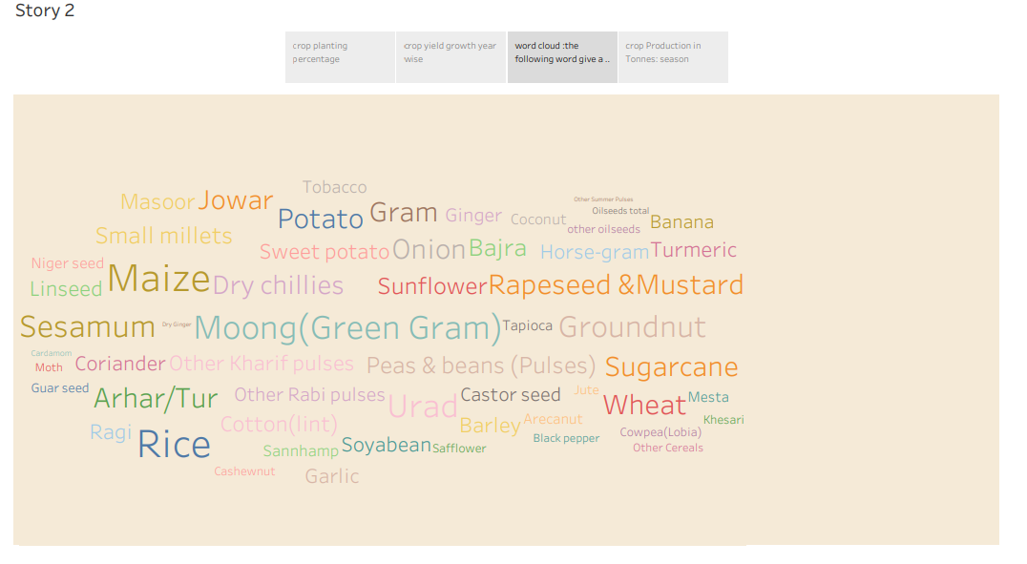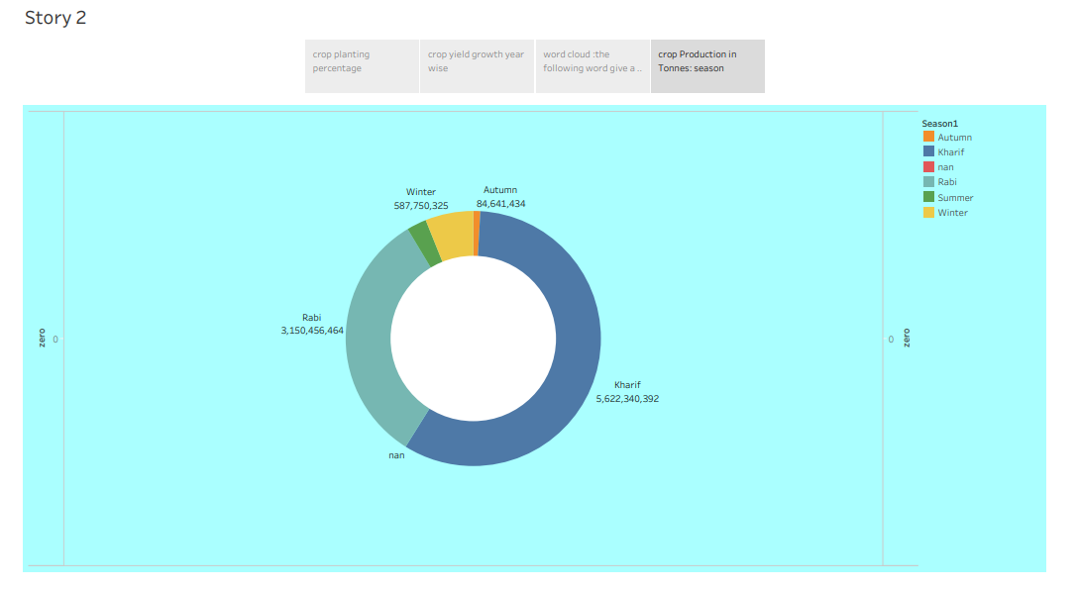

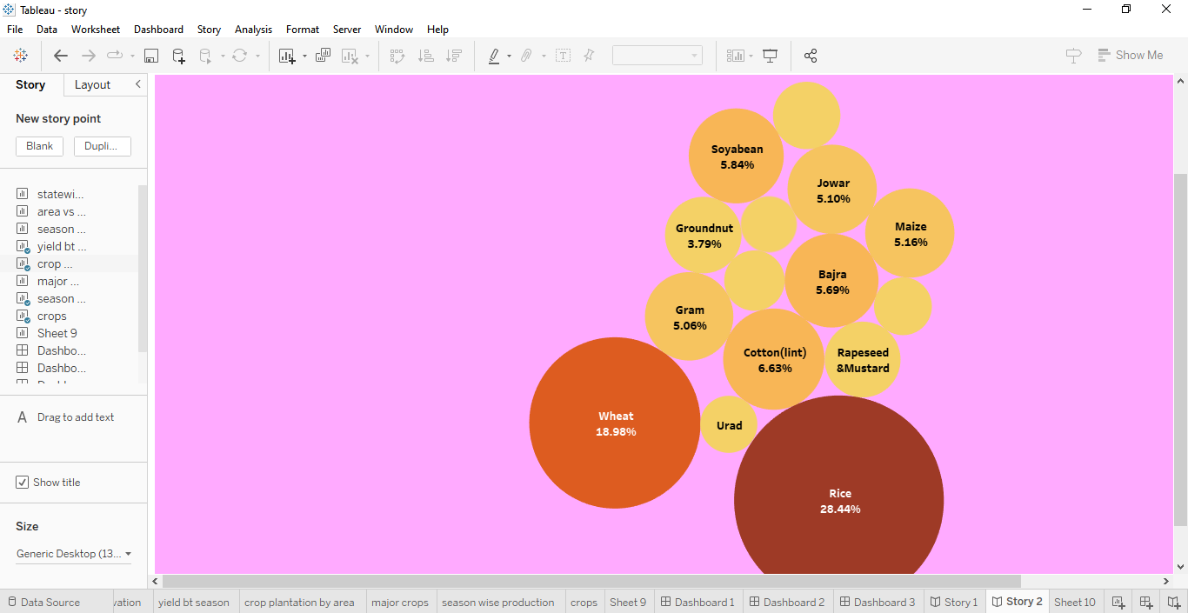

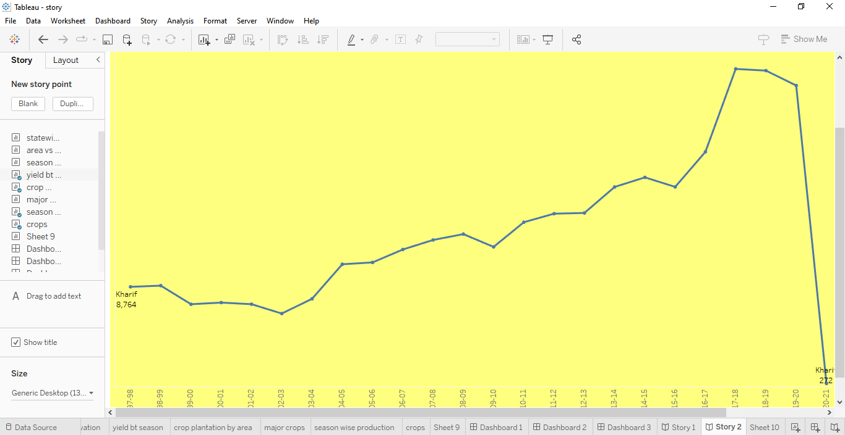

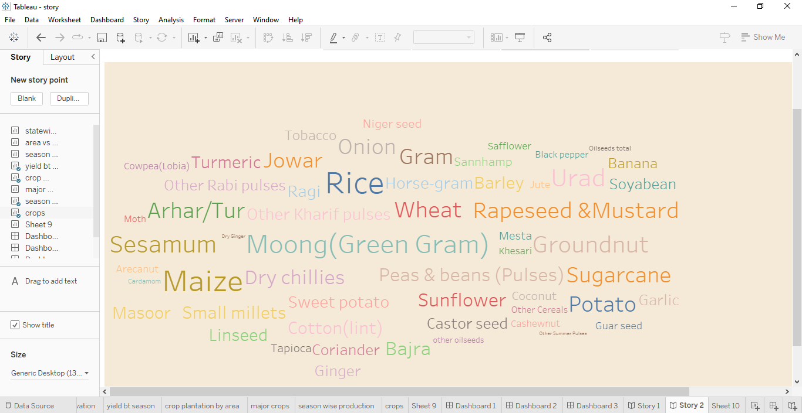

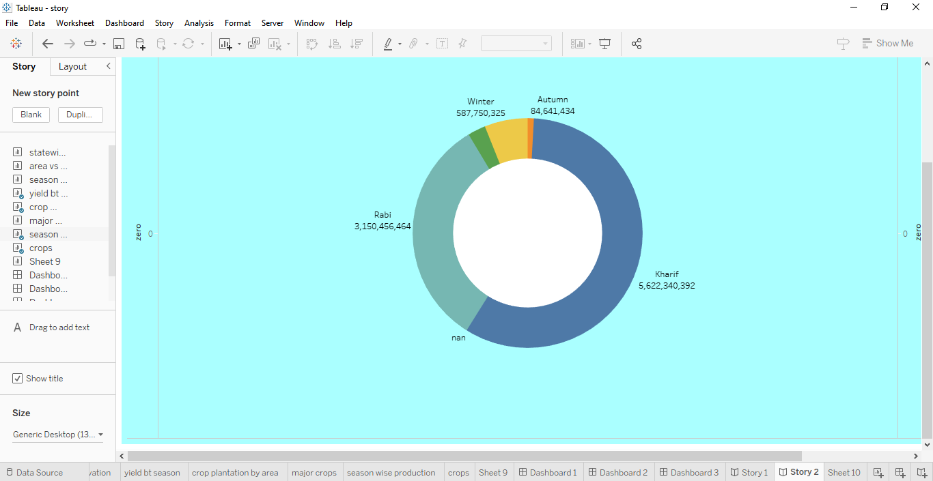

ADVANTAGES:

* Sustainable Farming: Embracing sustainable farming practices ensures the long-term viability of agriculture by minimizing environmental impact and preserving natural resources.
* Economic Growth and Employment: Enhanced crop production stimulates economic growth by creating new job opportunities, boosting rural economies, and contributing to the country's GDP.
* Technology Adoption and Innovation: Encouragement of technology adoption fosters innovation within the agricultural sector, promoting a culture of continuous improvement and modernization.
* Diversified Crop Portfolio: Crop diversification reduces dependency on a single crop and provides resilience against market fluctuations, thereby ensuring a stable income for farmers.

* Water Efficiency: Efficient water management techniques lead to improved water usage, reducing wastage and making agriculture more sustainable, especially in water-scarce regions.

DISADVASNTAGES

Dependency on Monsoon: Indian agriculture heavily relies on the monsoon season, making it vulnerable to erratic weather patterns and rainfall variations.

Lack of Modern Technology: Many farmers still use traditional farming methods and lack access to modern agricultural technology and machinery, impacting productivity and efficiency.

Land Fragmentation: Land holdings are often small and fragmented, leading to suboptimal utilization of resources and hindering economies of scale.

Crop Losses Due to Pests and Diseases: Pests, diseases, and inadequate pest management practices can lead to significant crop losses, affecting overall yields and farmer incomes.

Limited Irrigation Infrastructure: Uneven distribution and inadequate irrigation facilities result in water scarcity during critical growth periods, affecting crop yields and quality.

APPLICATIONS

Export and Trade: India is a major exporter of various agricultural commodities, including rice, spices, tea, coffee, cotton, and fruits. Crop production caters to international markets, boosting the country's export earnings.

Biofuel Production: Certain crops, like sugarcane and oilseeds, are used in the production of biofuels like ethanol and biodiesel, promoting sustainable energy sources and reducing dependence on fossil fuels.

Textile Industry: Cotton, a major crop in India, is used in the textile industry to produce clothing, fabrics, and various textile products, supporting both domestic consumption and export.

Pharmaceuticals and Medicinal Plants: India's diverse agriculture includes the cultivation of medicinal plants and herbs, which are vital for the pharmaceutical industry in producing traditional and modern medicines.

Agro-Processing Industries: Agricultural crops serve as raw materials for a range of agro-processing industries such as food processing, dairy, flour milling, oil extraction, and more, adding value to the produce.

CONCLUSION:

India's agriculture crop production is a critical component of its economy, providing livelihoods to millions. However, challenges such as outdated farming practices, dependency on monsoons, and land fragmentation hinder optimal productivity. Solutions involve modernizing techniques, improving irrigation infrastructure, promoting sustainable farming practices, and investing in research and technology. Additionally, supporting farmers through government initiatives, ensuring fair prices, and enhancing market accessibility can help boost crop production and address food security concerns in the nation.